Lesson 8 - Writing the Conclusion

We know those body paragraphs can get a bit messy. Don’t worry and keep practicing! Let’s move on to the conclusion now and ensure we all know how to finish this assessment. Remember: don’t just summarize and rehash everything you’ve already said. Instead, we want to synthesize ideas and reach out for further implications.

Part 1: Watch the Conclusion Video

We like to tell our students that conclusions need to have three parts: (1) restatement of the thesis, (2) synthesis of ideas, and (3) final idea that ends with a flourish. See if you can find the 3 parts in the video.
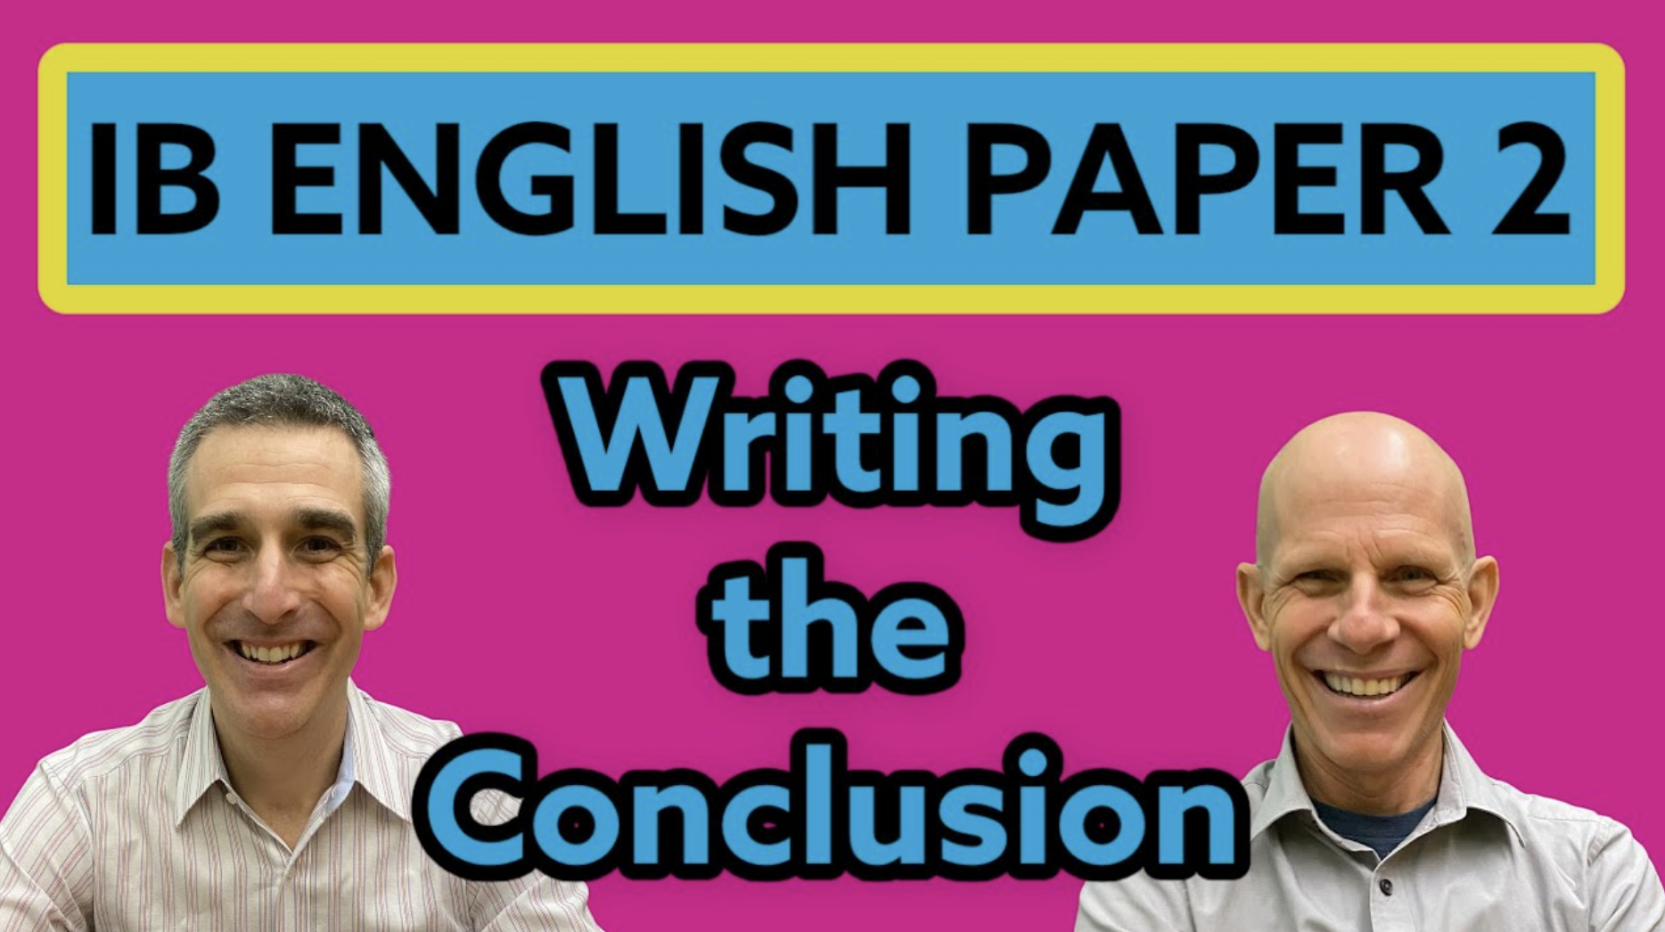

Video Link

Part 2: Read the Sample Conclusion and Identify the Parts

The video clearly identifies three parts of conclusions that examiners like to spot. To refresh your memory, here are the key components:

- Restatement of your thesis
- Synthesis of the paper without rehashing your main ideas. AVOID summarizing main ideas.
- Extension beyond the texts to a wider context. Answer the question, “So What?” End with a flourish!

And here there are in our sample:

Both men in these stories face immense challenges in being understood by their families and their communities. They both find themselves lost in a sense. The father in Family Supper is losing the traditional way of life and he is losing his family in the process. The father in Stones is losing his place in his community and losing the dignity he had prior to the war. As older men and as fathers, they are losing their grip and it is not until their sons are ready that they can finally be understood. Although both stories end on a melancholy note, both authors are sending a critical message to their readers about families and their struggles and the potential for understanding.

***Like all work we offer students, it is important to evaluate the work and not simply assume everything is a perfect 7. So, to what extent do you think this paper ends with a flourish? What might you tell this student to help them improve their work?

Part 3: Your Turn!

Give the conclusion to your paper a try. Be sure to keep those three key elements in mind while you write. When finished, highlight your work to prove to yourself and others that your conclusion will satisfy even the stingiest of examiners!

